**MENEDŻERSKA AKADEMIA NAUK STOSOWANYCH W**

**WARSZAWIE**

**55 DPH COMPUTER ENGINEERING**

metin içeren bir resim

Açıklama otomatik olarak oluşturuldu

**Mini Project in Python**

## SUPERVISOR

KUMAR NALINAKSH

2023 POLAND, EU

# Table of Content

User Documentation ............................................................................................. 3

User Manual........................................................................................................... 3

Code Information .................................................................................................. 4

Guidelines...............................................................................................................4

Submission Guidelines............................................................................................6

User Manual Weather Application ........................................................................6

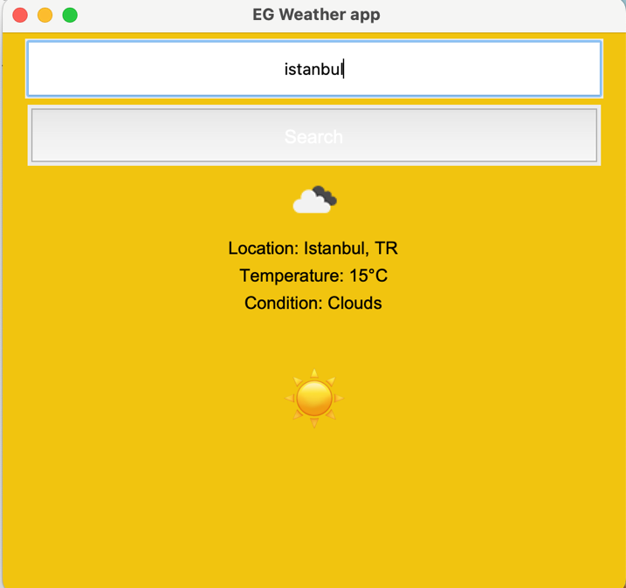

# **User Manual Documentation**

Shape of symbol changes based on temprature of a city or a country

Click on search botton to make result apper

Search for any city or country

# User's manual

1- Make sure you have installed Python 3.x on your computer.

2-Use the following commands to install the required libraries:

pip install tkinter

pip install pillow

pip install requests

3- Paste the Python code above into a Python file and save it (for example: Enver Gıdıcı 77797weather_app.py).

4-Replace your OpenWeatherMap API key with the value 'ebdaf471ca8fdbb689bb77234377f9a1' in the place assigned to the api_key variable. If you don't have the key, you can get a free API key from the OpenWeatherMap website.

5- To run the program, open a command line and enter the following command:

python weather_app.py

6- The application will launch and a window will be displayed.

7- Enter the city name in the search box and click the "Search" button or press Enter.

8- Weather information and images will be displayed in the window.

9- You can repeat the steps to query another city.

10- close app

# CODE INFORMATION

Click on run button to test the code

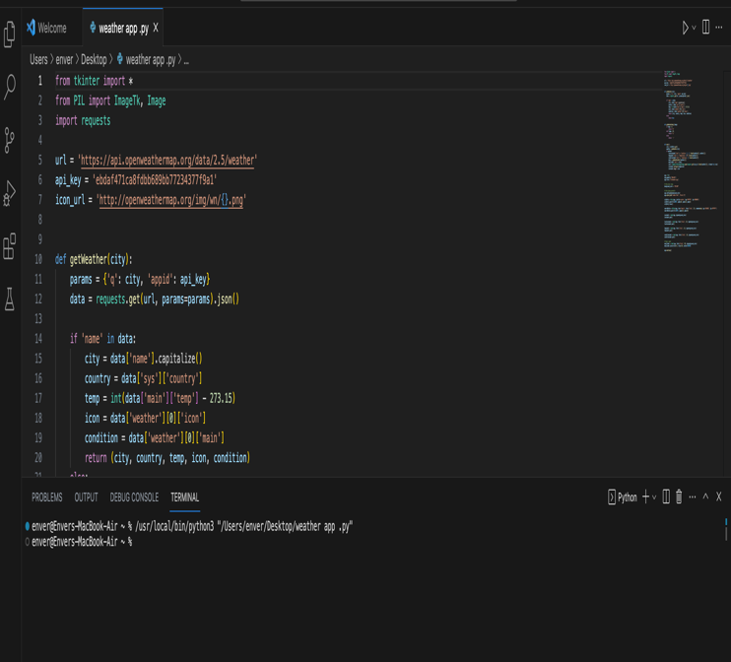

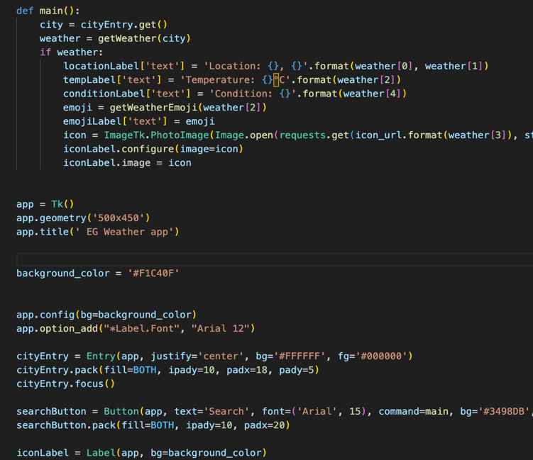

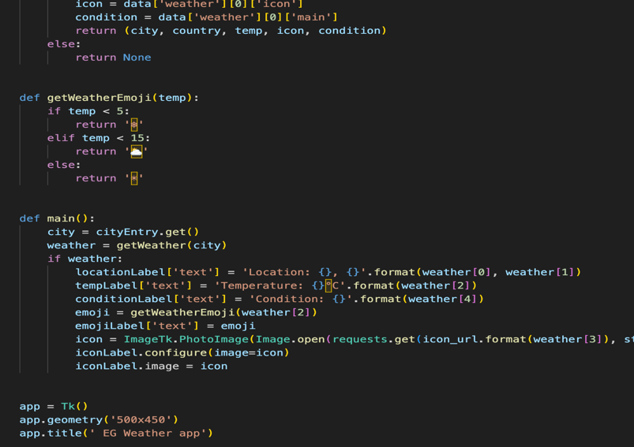

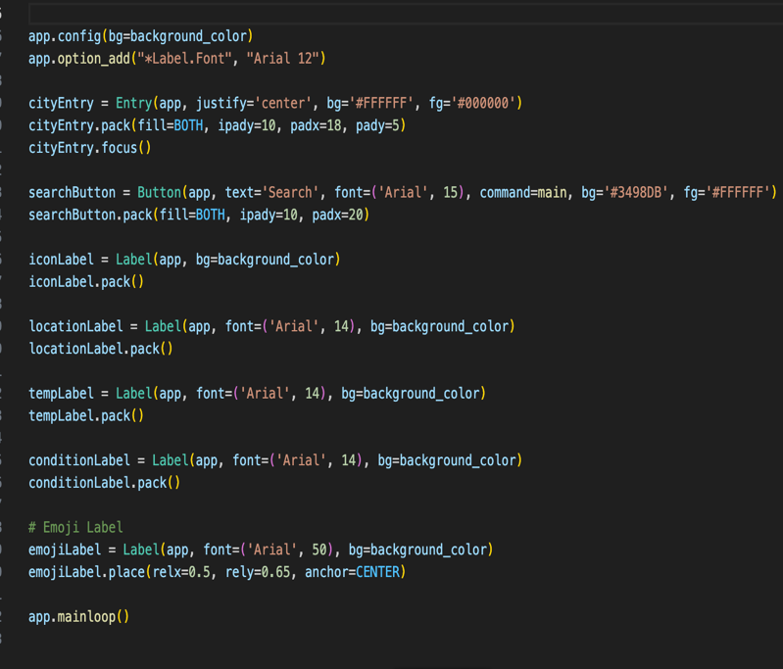 Code End

# Guidelines

1- When you run the program, a graphical interface is displayed

2- In the search box, enter the city name for which you want to query the weather.

3- Click the "Search" button or press Enter.

4- The program retrieves weather data using the OpenWeatherMap API.

5- If the city is found, the following information is displayed on the screen:

Location: City Name, Country Code

Temperature: degrees Celsius

Weather Condition: Ex. Sunny, Cloudy, Rainy etc.

Weather Icon: An icon that visually represents the weather condition

Weather Emoticons: Emojis that change depending on the temperature value

6- If the city is not found, an error message is displayed.

7- If the city is not found, an error message is displayed.

# Submission Guidelines

1. Open the Python file and copy its contents.

2. Paste the file in a text editor.

3. Save the file with a suitable name such as weather_app.py.

4. Replace your API key with the value 'ebdaf471ca8fdbb689bb77234377f9a1' assigned to the api_key variable. If you don't have the key, you can get a free API key from the openWeather app website.

5. Make sure the required libraries are installed. If they are not installed, open the command line and run the following commands in order:

pip install tkinter

pip install pillow

pip install requests

6. Open terminal or command prompt.

7. Enter the following command to run the Python script:

python weather_app.py

8. The program will start and a window will be displayed.

9. Enter the city name in the search box and click the "Search" button or press the Enter key.

10. Weather information and images will be displayed in the window.

11. You can repeat the steps to query another city.

12. To close the application, close the window or use the Ctrl+C combination in the command line.

13. In this way, you can make weather inquiries using the program

# User Manual: Weather Application

Install Required Libraries

Make sure the following libraries are installed for the app to work:

tkinter

PIL (Python Imaging Library)

requests

Get OpenWeatherMap API Key

An API key is required to use the OpenWeatherMap API. If you don't have the key, you can get a free API key from the OpenWeatherMap website.

Prepare the Python File

Using a text editor or Python IDE, create a file containing the following Python code:

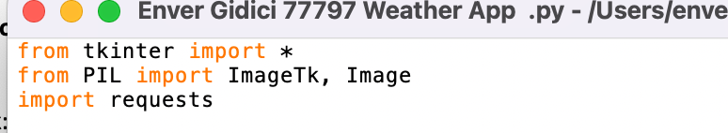

Add API Key

Go to the beginning of the Python file and find the api_key variable:



Add Required Functions and Codes

Add the following functions and code to the rest of the Python file:

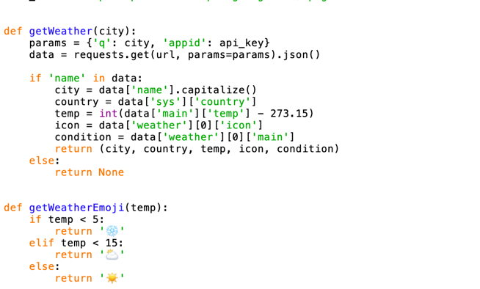



Create Interface Elements and Layout

Add the following code in the appropriate place of the Python file:

